Experiment Seven And Eight

Design And Hardware Verification Of A SEVEN SEGMENT DECODER

Jesse Lai

Department of Electrical & Computer Engineering
University Of Missouri-Rolla

CpE 112, Section H
Lab Partner: Alicia Lee
December 3, 1999

Abstract

Seven segment displays, such as those used in digital clocks, are an important aspect in today’s modern digital world as a form of visual output. This experiment is intended to be a walkthrough in the design and hardware verification of a seven segment decoder. The basic logic to run a display is created from the knowledge of the hardware, then translated into a logic circuit using a schematic capture tool. After the design is simulated, it can be verified in the hardware format using a field programmable gate array. The bottom up approach for designing a complicated logic system is given in the following experiment.

Table Of Contents

Abstract i

Table Of Figures iii

- Introduction 1

- Background 2

- Procedure 4

Preliminary 4
Seven Segment Decoder Design 4
Seven Segment Decoder Simulation 5
Seven Segment Decoder Bit File Creation 6
Seven Segment Decoder Hardware Verification 6

- Analysis 8

- Conclusion 9

- Works cited 10

Appendixes 11

  - Truth Table 12
  - Logic Simplification 13
  - Kingbright Data Sheets 14
  - Xilinx 4005E FPGA Data Sheets 16
  - Materials 19
  - Seven Segment Decoder Schematic 20
  - FPGA Schematic 21
  - List Output 22
  - Waveform Output 23
  - Bit File Analysis 24
  - Manual Hardware Verification Circuit Diagram 32
  - Oscilloscope Measurements 33
  - Propagation Delay Summary 36

Table Of Figures

Figure Page

- Seven Segment Display 2
- Seven Segment Output Combinations 3

I. Introduction

This experiment is intended to be a walk-through manual on the design and verification of a seven segment display decoder. Seven segment displays are commonplace in many of today’s electronic devices as a means of visual output. An understanding of how and a seven segment LED works is required to begin the design process. This is explained in the background section of the report. After creating the fundamental truth table, the logic for each of the seven segments can be created. From this step, the logic circuit will be laid out using Mentor Graphics software to simulate the decoder and create the bit file necessary to hardware test the design. A Xilinx Field Programmable Gate Array (FPGA) can then be programmed with the decoder bit file to actually see the design in action.

II. Background

Seven segment displays are a common item in many of today’s electronic systems as a visual output device. Light emitting diodes (LEDs) and liquid crystal displays are two common technologies used to implement these components. Seven segment displays constructed from LEDs almost always have either the anode or cathode of each LED electrically connected. These are referred to as common anode or common cathode respectively. Common cathode displays are called active high since the common cathode is tied to ground. Then each segment anode is connected to a segment driver through a current limiting resistor, and a logic high output turns the segment on. Common anode displays are called active low because the common anode is tied to the positive power supply, usually 5 volts, and each segment cathode is tied to a segment driver through a current limiting resistor, which means a logic low turns the segment on. [3]
The type of display that will be used in this experiment is the common anode technology. These displays are better suited for use with TTL devices because the TTL device can sink more current than it can source. The Kingbright SA03-2HBD seven segment display will be used in this experiment. The data sheet can be found in Appendix C.
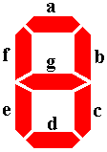
Figure 1 - Seven Segment Display

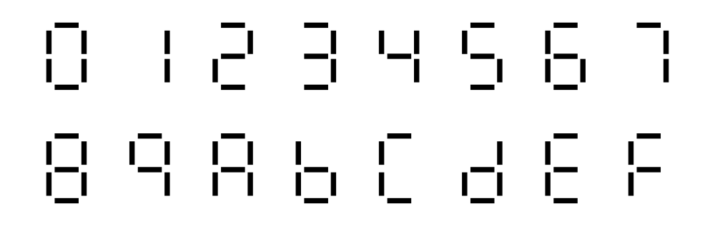
Figure 2 – Seven Segment Output Combinations

The Xilinx 4005E FPGA will be used for rapid hardware prototyping. FPGA technology allows for fast and efficient verification of hardware designs and can be reused many times during one life cycle.

III. Procedure

Preliminary:

- The hardware specifications of the LED display to be used were examined, and it was discovered that a logic ‘0’ would enable a segment and a logic ‘1’ would disable a segment.

- Knowing this, a truth table was created for each of the digits in the hexadecimal system. The truth table created is shown in Appendix A.

- From this truth table, Karnaugh maps were used to simplify the Boolean algebra equations created for each segment of the display. The Sum Of Products method was used for this experiment. The Karnaugh maps and their simplification can be found in Appendix B.

Seven Segment Decoder Design:

- After logging into a Sun Workstation, a new directory should be created for this experiment. The command ‘mkdir digital3’ was used to accomplish this.

- After changing to the digital3 directory, the following commands were typed: ‘swd’ which set the current directory as the working directory, and ‘sul’ which set the current directory as the path to look for user libraries.

- Design Architect was then started by typing ‘da’ from the prompt.

- A new sheet was created by pressing the F1 key. This sheet was labeled “7seg.”

- The Xilinx libraries were accessed by clicking on Libraries>Xilinx Libraries from the main menu. The XC4000e subset was then selected, and all parts were displayed. To show the scroll bars in the windows, the RMB button was clicked and “Show Scroll Bars” was selected from the popup menu.

- Four input portin components were placed in the sheet. These were labeled by moving the cursor over the component and pressing the Shift-F7 key. The inputs were labeled as 8, 4, 2, and 1 in order from most significant bit to least significant bit.

- The logic for the decoder from the simplified Karnaugh maps was then laid out on the sheet using the inverter, AND2, AND3, AND4, OR3, and OR4 components where appropriate.

- The output portout components were placed as the output for each segment. These were labeled as a, b, c, d, e, f, and g in the same fashion that the inputs were labeled. The complete logic circuit can be found in Appendix F.

- The sheet was then checked by clicking on Check>Sheet from the main menu. There should be no errors at this point. The file was then saved.

- All components were unselected by pressing the F2 key. A symbol for the seven segment decoder was created by clicking on Miscellaneous>Generate Symbol from the main menu. The name “7seg” was used and the default options were left as given. The OK button was then clicked.

- After the symbol was created, the body of the symbol was selected with the LMB. Properties>Add>Single Property was selected from the Symbol Body and Pins Popup menu. REF was selected from Existing Property Name and “7seg” was filled in for the value. The OK button was then clicked. The name was placed at the top of the symbol by clicking the LMB at the point to place the title.

- All components were unselected and the sheet was checked as before. After verifying that there were no errors, the file was saved and the sheet was closed.

- A new sheet was created by pressing the F1 key and given the name “lab7.”

- An instance of the seven segment decoder symbol was added by clicking on Choose Symbol from the Schematic Palette. In the list that appeared, 7seg was selected. The symbol was then placed in the sheet.

- The pattern generator for the seven segment decoder was copied into the current user library by selecting MGC>Design Management>Copy from the main menu. The four arrows button was clicked in the dialog box that appeared. $UMRLIB was entered as the path to change to, and the OK button was clicked. The patgen component was selected. In the right pane of the dialog box, $USERLIB was entered. The OK button was then pressed.

- From the palette menu, Choose Symbol was clicked and an instance of patgen was placed in the sheet below the seven segment decoder.

- From the Xilinx 4005e library, input buffers and input pads were added to the input side of the pattern generator and seven segment decoder. Similarly, output buffers and output pads were added to the output side of these components. These nets were named as before with the names corresponding to that of the figure in Appendix G.

- The sheet was checked for errors as before. The file was then saved and Design Architect was closed.

Seven Segment Decoder Simulation:

- A viewpoint for simulation of the decoder in Quicksim was created by typing the following command from the prompt: pld_dve –s lab7 xc400e.

- Quicksim was started by typing ‘quicksim lab7’ from the prompt.

- A new bus for the input signals was created by clicking Setup>Define New Bus from the main menu. The bus was named “Inputs” and the signals P3, P4, P5, and P6 were added. The OK button was then clicked.

- The four inputs and the seven outputs of the decoder were selected in the Schematic window. List was selected from the Tool palette to add each of these signals to the List Window. Trace was selected from the Tool palette to add each of these signals to the Trace Window.

- All of the signals were unselected, and then only the four input signals were selected. Stimulus was selected from the Tool palette. Pattern Generator was then selected from the Stimulus palette. The bus “Inputs” was entered as the signal to generate patterns for. The duration for each pattern was chosen to be 100 nanoseconds and the total number of patterns to generate was 16. The OK button was then pressed.

- With the Trace Window active, the simulation was run for 1600 nanoseconds by typing the command: run 1600.

- The outputs were compared to the expected results to check for errors.

- Quicksim was then exited without saving the results.

Seven Segment Decoder Bit File Creation:

- The bit file for the seven segment decoder was created by typing the following command from the prompt: xmake lab7 xc4000e xc4005e-1-pc84.

- The bit file was transferred to the Novell account by typing ‘ftp UMR-ECE-FS1’ from the prompt. The user name and password were then entered.

- The command ‘binary’ was entered to change the transfer mode to binary. The command ‘put lab7.bit’ was used to transfer the bit file. The command ‘bye’ was used to log off of the FTP server.

Seven Segment Decoder Hardware Verification:

- The circuit shown in Appendix K was created on a breadboard. Each of the DIP switches went to one input on the FPGA, pins 3, 4, 5, and 6. The wiring of the output segments from the FPGA to the inputs of the LED are shown. The resistors should be placed accordingly. Pins 3 and 14 of the LED were tied to V_{CC}.

- The completed circuit was attached to a five volt power supply and the maximum current was set to 150 mA. The output of the power supply was turned on.

- The Xilinx Computer cable was attached to the Xilinx FPGA.

- The program Xilinx XACT Hardware Debugger M1.5.25 was started, and the bit file created earlier was opened.

- This FPGA was then programmed using the information stored in the bit file.

- The seven segment decoder was verified by cycling through each of the 16 possible combinations of the DIP switch inputs. When the DIP switch was closed, this tied the line to ground producing a logic ‘0’. When the DIP switch was open, this connected the line to VCC producing a logic ‘1’.

- The circuit was disassembled and the outputs of the pattern generator were connected directly to the inputs of the seven segment decoder. The pin were connected as follows: Pin 10 – Pin 3, Pin 9 – Pin 4, Pin 8 – Pin 5, Pin 7 – Pin 6.

- Pin headers were used to connect the digital scope leads of the HP 54645 MSO to the four input pins, 3, 4, 5, and 6, as well as the seven output pins, 78, 79, 80, 81, 82, 83, and 84.

- The completed circuit was attached to a five volt power supply as before and the bit file was downloaded in the same fashion.

- The MSO was used to again verify the functionality of the seven segment decoder as well as the effects of propagation delay through the circuit. These results are summarized in Appendix M.

IV. Analysis

A great deal of information can be obtained by reviewing the information generated by the xmake process. The original design for the seven segment decoder used 112 primitive logic gates. An examination of the map.mrp output file shows that the design used eight configurable logic blocks. Obviously Mentor Graphics simplifies the design to use the least number of primitive logic gates. However, for the design to only use eight configurable logic blocks, this must mean that each has multiple outputs.
The seven segment display functioned as designed with complementary results from both the manual testing with the DIP switch and the testing using the pattern generator. There was propagation delay through the circuit. These delay measurements are shown in Appendix L. The propagation delay caused by the rising and falling edge of the signal D3 was the same, clocked at 4.800 nanoseconds in this experiment. The propagation delay for the rising and falling edge on the D2 signal differed, however. The delay from the falling edge of D2 was 5.200 nanoseconds, while the delay from the rising edge of D2 was 10.000 nanoseconds. This was one of the worst case propagation delays. The propagation delay from the D1 signal was 10.000 nanoseconds. This was the second worst case propagation delay. The propagation delay from the D0 signal was 5.200 nanoseconds. A table summarizing these data is located in Appendix M.

V. Conclusion

Seven segment displays are an important aspect of everyday life. It was shown in this experiment that the design and implementation of such a display is made easier with the assistance of advanced design tools. The driving concept behind the logic of the seven segment decoder was not very complex, but the design was greatly simplified using Mentor Graphics software to capture the schematic.
These design tools also allowed for the design to be tested even before prototyping the decoder in hardware. Simulating the decoder using the design tools allows for errors to be detected before the actual design is implemented in hardware. If a faulty design is implemented in hardware, and the error is not discovered until after the fact, a great deal of time and money was wasted. That is the reason behind the extensive testing of the seven segment decoder using the simulation software in this experiment.
After the design was verified in the simulation stage, it was then necessary to verify the design in the hardware stage. The design tools correctly implemented the seven segment decoder for testing using a field programmable gate array. After verification of the correct results in the hardware phase, it was then useful to measure the effects of propagation delay on the circuit. The delay though the circuit was measured for various inputs to outputs in the decoder.
This experiment has shown the bottom up approach to designing a seven segment decoder. Aided with power of modern design tools, the decoder could be simulated before hardware implementation. This can be extended to larger, more complex digital systems, giving the designer much more power and flexibility in their design.

VI. Works Cited

- SA03-11 Graphic display. Kingbright. November 13, 1999 <http://www.kingbright.com/catalog/p74_1g.pdf>.

- Single Digit Numeric Displays. Kingbright. November 13, 1999 <http://www.kingbright.com/catalog/74.pdf>.

- University of Missouri-Rolla Department of Electrical Engineering. EE 112 Computer Engineering Laboratory Manual. Barnes & Noble, August 1999. Pages 7-1 – 8-1.

- Xilinx Data Book – FPGA and CPLD Products. Xilinx. November 17, 1999 <http://www.xilinx.com/partinfo/databook.htm>.

Appendixes

Appendix A

Truth Table

Seven Segment Display Truth Table
Hex | A | B | C | D | a | b | c | d | e | f | g
0 | 0 | 0 | 0 | 0 | 0 | 0 | 0 | 0 | 0 | 0 | 1
1 | 0 | 0 | 0 | 1 | 1 | 0 | 0 | 1 | 1 | 1 | 1
2 | 0 | 0 | 1 | 0 | 0 | 0 | 1 | 0 | 0 | 1 | 0
3 | 0 | 0 | 1 | 1 | 0 | 0 | 0 | 0 | 1 | 1 | 0
4 | 0 | 1 | 0 | 0 | 1 | 0 | 0 | 1 | 1 | 0 | 0
5 | 0 | 1 | 0 | 1 | 0 | 1 | 0 | 0 | 1 | 0 | 0
6 | 0 | 1 | 1 | 0 | 0 | 1 | 0 | 0 | 0 | 0 | 0
7 | 0 | 1 | 1 | 1 | 0 | 0 | 0 | 1 | 1 | 1 | 1
8 | 1 | 0 | 0 | 0 | 0 | 0 | 0 | 0 | 0 | 0 | 0
9 | 1 | 0 | 0 | 1 | 0 | 0 | 0 | 1 | 1 | 0 | 0
A | 1 | 0 | 1 | 0 | 0 | 0 | 0 | 1 | 0 | 0 | 0
B | 1 | 0 | 1 | 1 | 1 | 1 | 0 | 0 | 0 | 0 | 0
C | 1 | 1 | 0 | 0 | 0 | 1 | 1 | 0 | 0 | 0 | 1
D | 1 | 1 | 0 | 1 | 1 | 0 | 0 | 0 | 0 | 1 | 0
E | 1 | 1 | 1 | 0 | 0 | 1 | 1 | 0 | 0 | 0 | 0
F | 1 | 1 | 1 | 1 | 0 | 1 | 1 | 1 | 0 | 0 | 0

Appendix B

Logic Simplification

Karnaugh Map Simplification:
Segment a |  |  |  |  |  |  | Segment e
 | CD |  |  |  |  |  |  | CD
AB |  | 00 | 01 | 11 | 10 |  | AB |  | 00 | 01 | 11 | 10
 | 00 |  | 1 |  |  |  |  | 00 |  | 1 | 1
 | 01 | 1 |  |  |  |  |  | 01 | 1 | 1 | 1
 | 11 |  | 1 |  |  |  |  | 11
 | 10 |  |  | 1 |  |  |  | 10 |  | 1
Segment b |  |  |  |  |  |  | Segment f
 | CD |  |  |  |  |  |  | CD
AB |  | 00 | 01 | 11 | 10 |  | AB |  | 00 | 01 | 11 | 10
 | 00 |  |  |  |  |  |  | 00 |  | 1 | 1 | 1
 | 01 |  | 1 |  | 1 |  |  | 01 |  |  | 1
 | 11 | 1 |  | 1 | 1 |  |  | 11 |  | 1
 | 10 |  |  | 1 |  |  |  | 10
Segment c |  |  |  |  |  |  | Segment g
 | CD |  |  |  |  |  |  | CD
AB |  | 00 | 01 | 11 | 10 |  | AB |  | 00 | 01 | 11 | 10
 | 00 |  |  |  | 1 |  |  | 00 | 1 | 1
 | 01 |  |  |  |  |  |  | 01 |  |  |  | 1
 | 11 | 1 |  | 1 | 1 |  |  | 11 | 1
 | 10 |  |  |  |  |  |  | 10
Segment d
 | CD
AB |  | 00 | 01 | 11 | 10
 | 00 |  | 1
 | 01 | 1 |  | 1
 | 11 |  |  | 1
 | 10 |  | 1 |  | 1

Sum Of Product Equations:
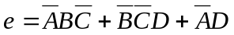
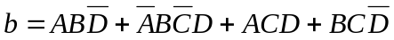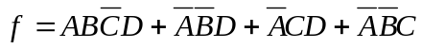
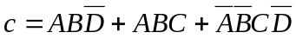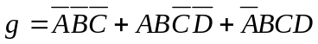

Appendix C

Kingbright Data Sheets

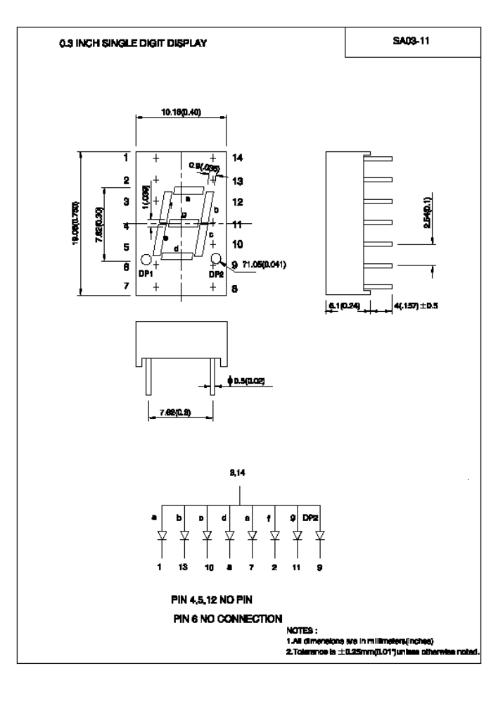
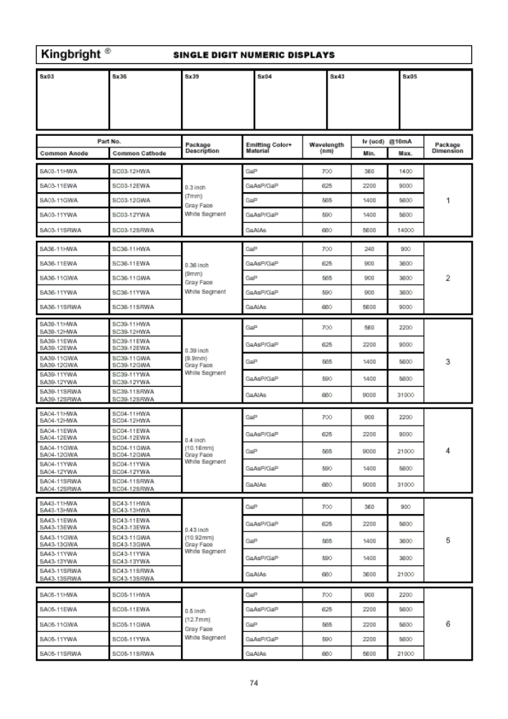

Appendix D

Xilinx 4005E FPGA Data Sheets

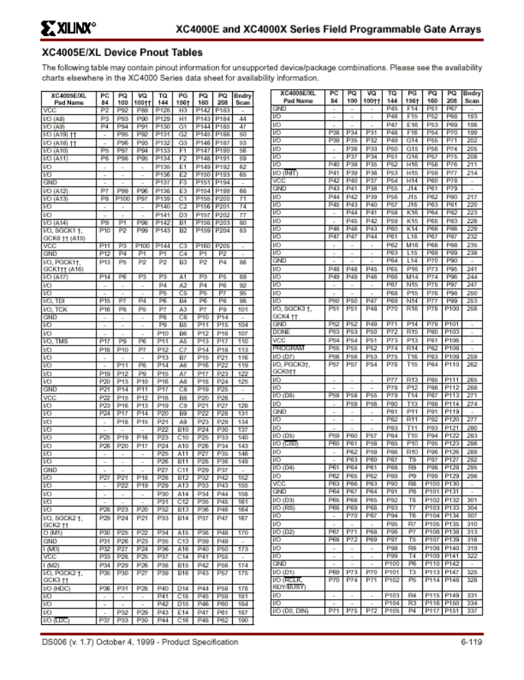
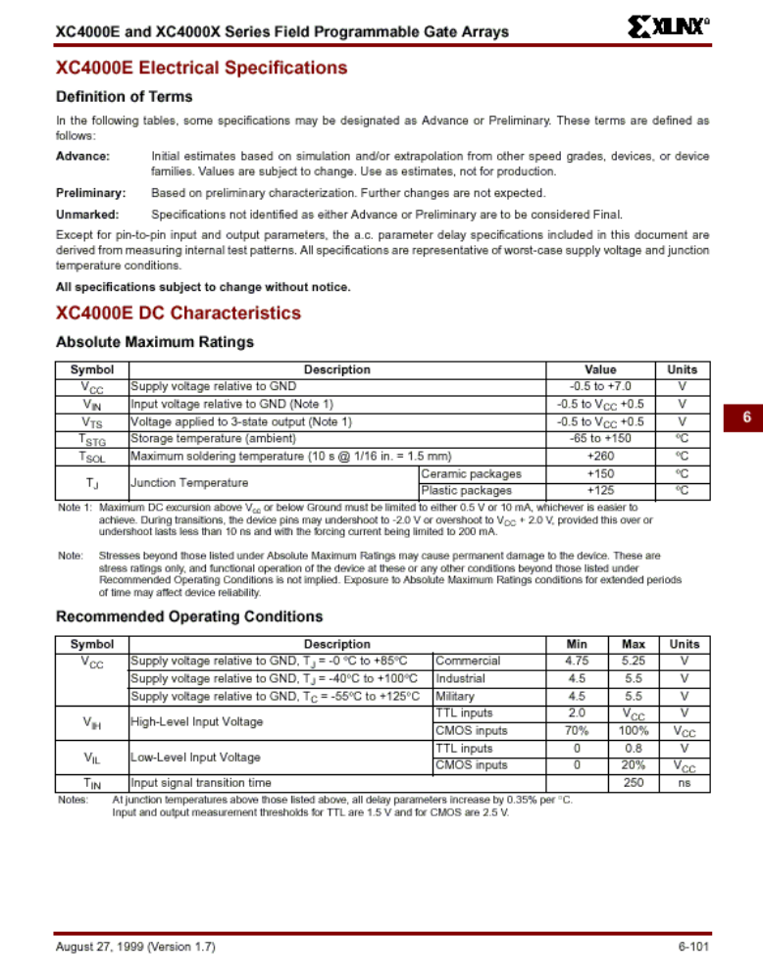
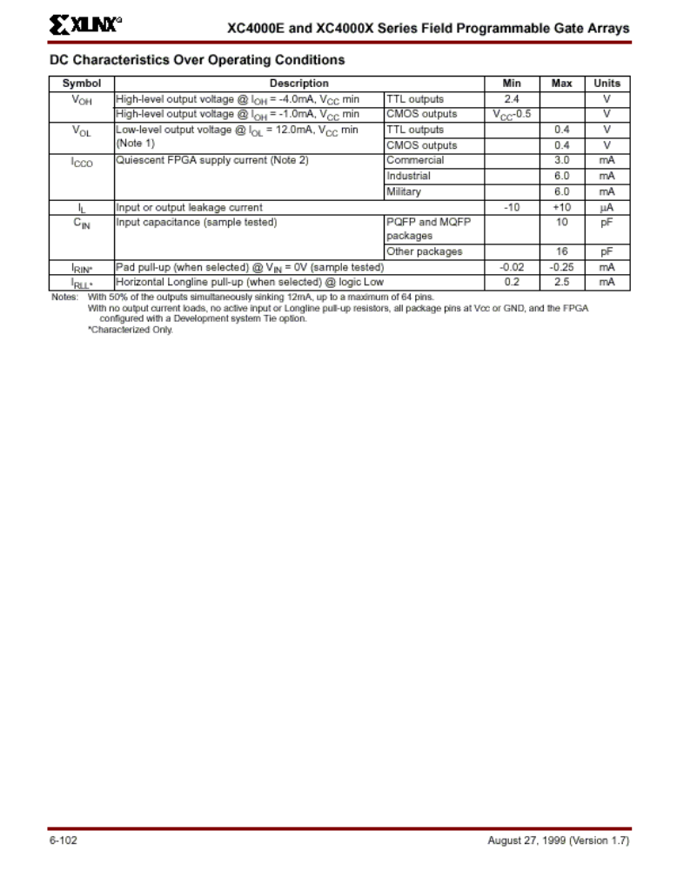

Appendix E

Materials

- 4 – 1 kΩ Resistors
- 7 – 390 Ω Resistor
- Breadboard
- DIP Switch
- HP34810B Benchlink Scope v1.5 Software
- HP54645 Mixed Signal Oscilloscope
- Kingbright SA03-12HBD Seven Segment Display
- Mentor Graphics Software
- Pin Headers
- Sun Workstation
- Tektronix PS5004 Precision Power Supply
- XC4005 Field Programmable Gate Array
- Xilinx Computer Cable
- Xilinx XACT Hardware Debugger M1.5.25 Software

Appendix F

Seven Segment Decoder Schematic
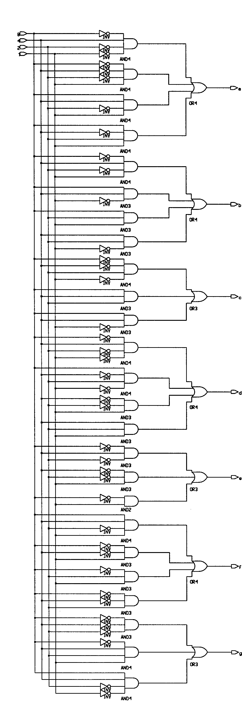

Appendix G

FPGA Schematic

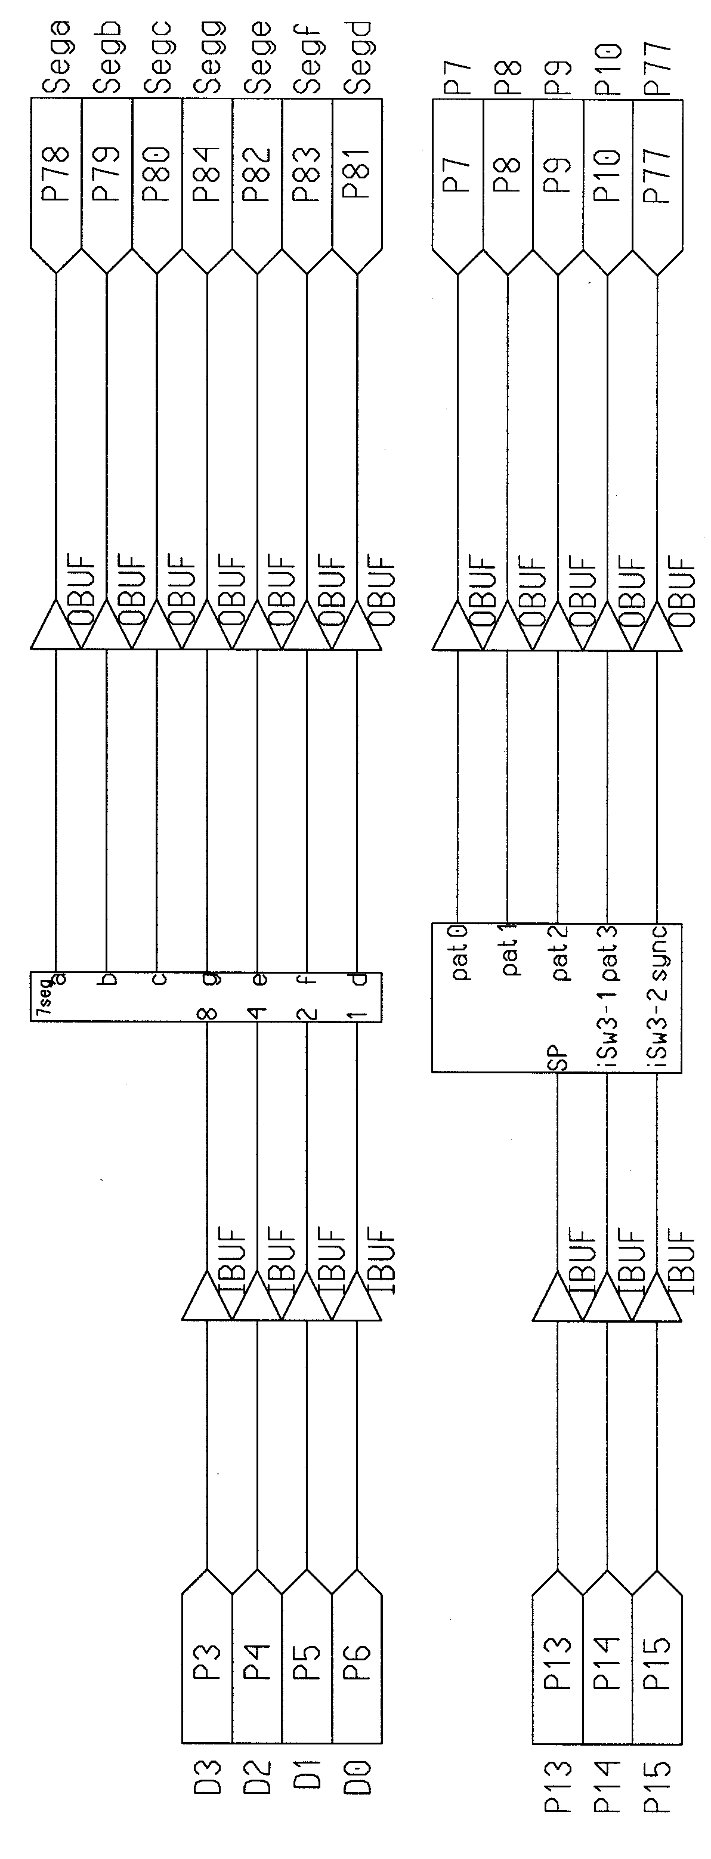

Appendix H

List Output

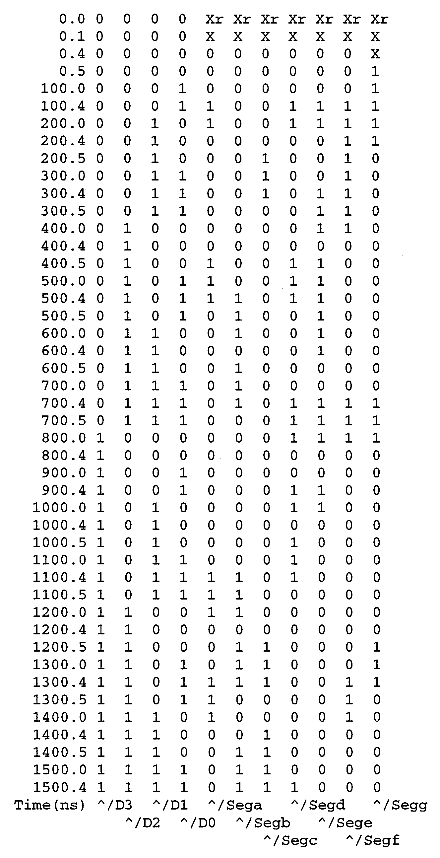

Appendix I

Waveform Output

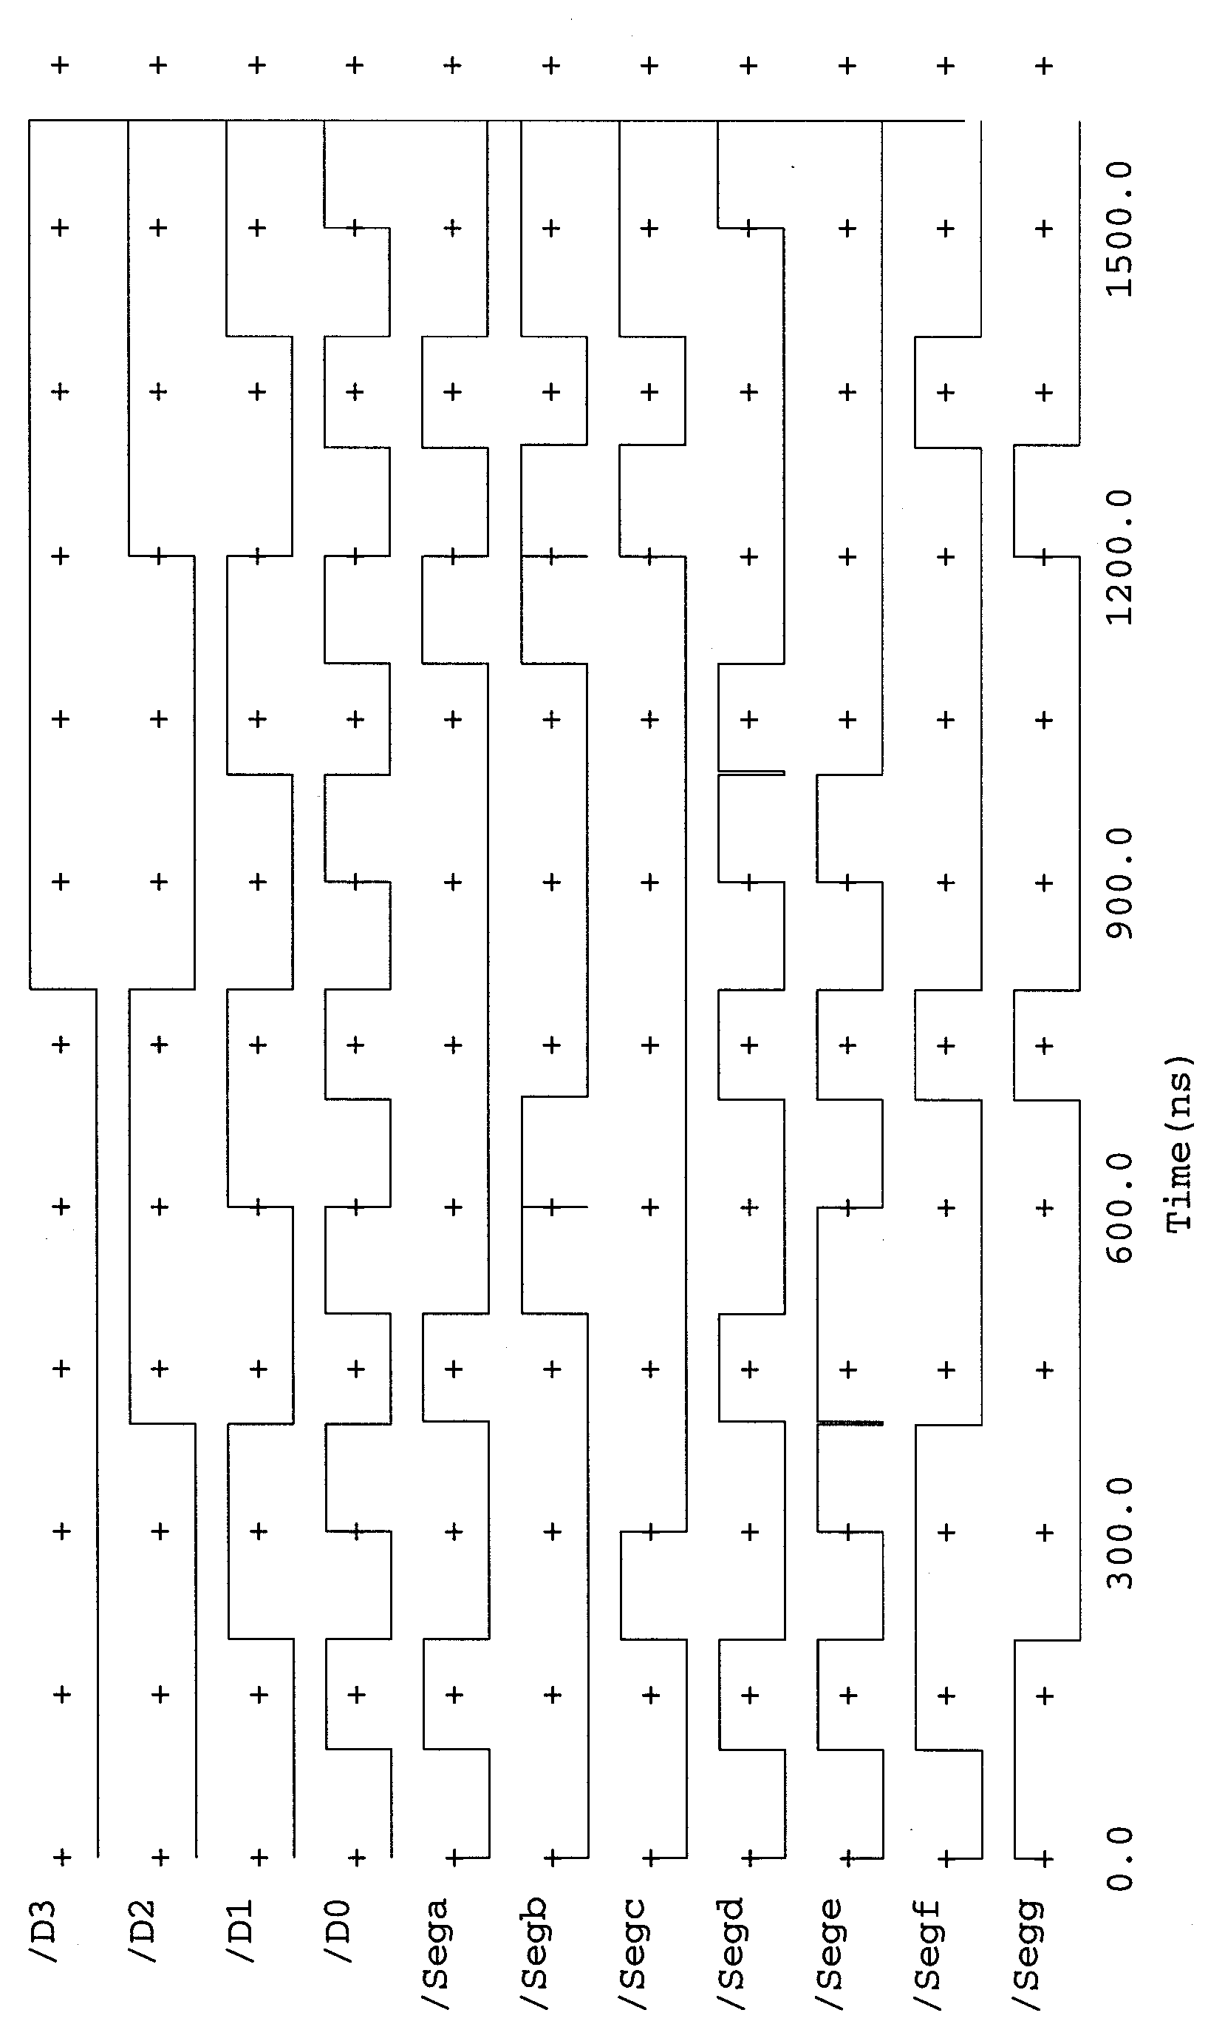

Appendix J

Bit File Analysis

File: lab7.dly

The 20 Worst Net Delays are:
-------------------------------
| Max Delay (ns) | Netname |
-------------------------------
3.652 N$9
3.342 I$431/N$12
3.247 N$412
2.993 N$8
2.896 N$1
2.869 N$209
2.724 I$431/N$10
2.682 I$431/N$11
2.407 N$205
2.318 N$411
2.094 N$208
1.910 N$12
1.840 N$207
1.797 N$6
1.493 N$413
1.427 N$206
1.409 N$14
1.377 N$2
1.318 I$431/N$1
1.100 N$5
---------------------------------

File lab7.pad

PAR: Xilinx Place And Route M1.5.25.
Copyright (c) 1995-1998 Xilinx, Inc. All rights reserved.
Fri Oct 29 13:13:46 1999

Xilinx PAD Specification File
*****************************

Input file: map.ncd
Output file: lab7.ncd
Part type: xc4005e
Speed grade: -1
Package: pc84

Fri Oct 29 13:13:46 1999

Pinout by Pin Name:
+------------------------------------------------+-----------+--------------+
| Pin Name | Direction | Pin Number |
+------------------------------------------------+-----------+--------------+
| P10 | OUTPUT | P10 |
| P13 | INPUT | P13 |
| P14 | INPUT | P14 |
| P15 | INPUT | P15 |
| P3 | INPUT | P3 |
| P4 | INPUT | P4 |
| P5 | INPUT | P5 |
| P6 | INPUT | P6 |
| P7 | OUTPUT | P7 |
| P77 | OUTPUT | P77 |
| P8 | OUTPUT | P8 |
| P9 | OUTPUT | P9 |
| Sega | OUTPUT | P78 |
| Segb | OUTPUT | P79 |
| Segc | OUTPUT | P80 |
| Segd | OUTPUT | P81 |
| Sege | OUTPUT | P82 |
| Segf | OUTPUT | P83 |
| Segg | OUTPUT | P84 |
+------------------------------------------------+-----------+--------------+
| Dedicated or Special Pin Name | Pin Number |
+------------------------------------------------------------+--------------+
| /PROG | P55 |
| CCLK | P73 |
| DONE | P53 |
| GND | P43 |
| GND | P12 |
| GND | P76 |
| GND | P52 |
| GND | P31 |
| GND | P21 |
| GND | P64 |
| GND | P1 |
| M0 | P32 |
| M1 | P30 |
| M2 | P34 |
| TDO | TDO |
| TDO | P75 |
| VCC | P11 |
| VCC | P54 |
| VCC | P42 |
| VCC | P63 |
| VCC | P22 |
| VCC | P2 |
| VCC | P33 |
| VCC | P74 |
+------------------------------------------------------------+--------------+

Pinout by Pin Number:
+--------------+-----------------------------------+-----------+------------+
| Pin Number | Pin Name | Direction | Constraint |
+--------------+-----------------------------------+-----------+------------+
| P1 | GND | | |
| P2 | VCC | | |
| P3 | P3 | INPUT | LOCATED |
| P4 | P4 | INPUT | LOCATED |
| P5 | P5 | INPUT | LOCATED |
| P6 | P6 | INPUT | LOCATED |
| P7 | P7 | OUTPUT | LOCATED |
| P8 | P8 | OUTPUT | LOCATED |
| P9 | P9 | OUTPUT | LOCATED |
| P10 | P10 | OUTPUT | LOCATED |
| P11 | VCC | | |
| P12 | GND | | |
| P13 | P13 | INPUT | LOCATED |
| P14 | P14 | INPUT | LOCATED |
| P15 | P15 | INPUT | LOCATED |
| P16 | | | |
| P17 | | | |
| P18 | | | |
| P19 | | | |
| P20 | | | |
| P21 | GND | | |
| P22 | VCC | | |
| P23 | | | |
| P24 | | | |
| P25 | | | |
| P26 | | | |
| P27 | | | |
| P28 | | | |
| P29 | | | |
| P30 | M1 | | |
| P31 | GND | | |
| P32 | M0 | | |
| P33 | VCC | | |
| P34 | M2 | | |
| P35 | | | |
| P36 | | | |
| P37 | | | |
| P38 | | | |
| P39 | | | |
| P40 | | | |
| P41 | | | |
| P42 | VCC | | |
| P43 | GND | | |
| P44 | | | |
| P45 | | | |
| P46 | | | |
| P47 | | | |
| P48 | | | |
| P49 | | | |
| P50 | | | |
| P51 | | | |
| P52 | GND | | |
| P53 | DONE | | |
| P54 | VCC | | |
| P55 | /PROG | | |
| P56 | | | |
| P57 | | | |
| P58 | | | |
| P59 | | | |
| P60 | | | |
| P61 | | | |
| P62 | | | |
| P63 | VCC | | |
| P64 | GND | | |
| P65 | | | |
| P66 | | | |
| P67 | | | |
| P68 | | | |
| P69 | | | |
| P70 | | | |
| P71 | | | |
| P72 | | | |
| P73 | CCLK | | |
| P74 | VCC | | |
| P75 | TDO | | |
| P76 | GND | | |
| P77 | P77 | OUTPUT | LOCATED |
| P78 | Sega | OUTPUT | LOCATED |
| P79 | Segb | OUTPUT | LOCATED |
| P80 | Segc | OUTPUT | LOCATED |
| P81 | Segd | OUTPUT | LOCATED |
| P82 | Sege | OUTPUT | LOCATED |
| P83 | Segf | OUTPUT | LOCATED |
| P84 | Segg | OUTPUT | LOCATED |
| TDO | TDO | | |
+--------------+-----------------------------------+-----------+------------+

#
# Pinout constraints listing
# These constraints are in PCF grammar format
# and may be cut and pasted into the PCF file
# after the "SCHEMATIC END ;" statement to
# preserve this pinout for future design iterations.
#
COMP "P10" LOCATE = SITE "P10" ;
COMP "P13" LOCATE = SITE "P13" ;
COMP "P14" LOCATE = SITE "P14" ;
COMP "P15" LOCATE = SITE "P15" ;
COMP "P3" LOCATE = SITE "P3" ;
COMP "P4" LOCATE = SITE "P4" ;
COMP "P5" LOCATE = SITE "P5" ;
COMP "P6" LOCATE = SITE "P6" ;
COMP "P7" LOCATE = SITE "P7" ;
COMP "P77" LOCATE = SITE "P77" ;
COMP "P8" LOCATE = SITE "P8" ;
COMP "P9" LOCATE = SITE "P9" ;
COMP "Sega" LOCATE = SITE "P78" ;
COMP "Segb" LOCATE = SITE "P79" ;
COMP "Segc" LOCATE = SITE "P80" ;
COMP "Segd" LOCATE = SITE "P81" ;
COMP "Sege" LOCATE = SITE "P82" ;
COMP "Segf" LOCATE = SITE "P83" ;
COMP "Segg" LOCATE = SITE "P84" ;
#
File map.mrp:

Xilinx Mapping Report File for Design "lab7"
Copyright (c) 1995-1998 Xilinx, Inc. All rights reserved.

Design Information
------------------
Command Line : /usr/local/xilinx.15i/bin/sol/map -p xc4005e-1-pc84 -o map.ncd
lab7.ngd lab7.pcf
Target Device : x4005e
Target Package : pc84
Target Speed : -1
Mapper Version : xc4000e -- M1.5.25
Mapped Date : Fri Oct 29 13:13:17 1999

Design Summary
--------------
Number of errors: 0
Number of warnings: 1
Number of CLBs: 8 out of 196 4%
CLB Flip Flops: 4
4 input LUTs: 14
3 input LUTs: 1
Number of bonded IOBs: 19 out of 61 31%
IOB Flops: 0
IOB Latches: 0
Number of oscillators: 1
Total equivalent gate count for design: 112
Additional JTAG gate count for IOBs: 912

Table of Contents
-----------------
Section 1 - Errors
Section 2 - Warnings
Section 3 - Design Attributes
Section 4 - Removed Logic Summary
Section 5 - Removed Logic
Section 6 - Added Logic
Section 7 - Expanded Logic
Section 8 - Signal Cross-Reference
Section 9 - Symbol Cross-Reference
Section 10 - IOB Properties
Section 11 - RPMs
Section 12 - Guide Report

Section 1 - Errors
------------------

Section 2 - Warnings
--------------------
WARNING:baste:24 - All of the external outputs in this design are using
slew-rate-limited output drivers. The delay on speed critical outputs can be
dramatically reduced by designating them as fast outputs in the original
design. Please see your vendor interface documentation for specific
information on how to do this within your design-entry tool.
Note: You should be careful not to designate too many outputs which switch
together as fast, because this can cause excessive ground bounce. For more
information on this subject, please refer to the IOB switching characteristic
guidelines for the device you are using in the Programmable Logic Data Book.

Section 3 - Design Attributes
-----------------------------
Attribute LOC
"P84" for signal(s) Segg on symbol "schematic/Segg"
"P83" for signal(s) Segf on symbol "schematic/Segf"
"P82" for signal(s) Sege on symbol "schematic/Sege"
"P81" for signal(s) Segd on symbol "schematic/Segd"
"P80" for signal(s) Segc on symbol "schematic/Segc"
"P79" for signal(s) Segb on symbol "schematic/Segb"
"P78" for signal(s) Sega on symbol "schematic/Sega"
"P9" for signal(s) P9 on symbol "schematic/P9"
"P8" for signal(s) P8 on symbol "schematic/P8"
"P77" for signal(s) P77 on symbol "schematic/P77"
"P7" for signal(s) P7 on symbol "schematic/P7"
"P6" on symbol "schematic/P6"
"P5" on symbol "schematic/P5"
"P4" on symbol "schematic/P4"
"P3" on symbol "schematic/P3"
"P15" on symbol "schematic/P15"
"P14" on symbol "schematic/P14"
"P13" on symbol "schematic/P13"
"P10" for signal(s) P10 on symbol "schematic/P10"

Section 4 - Removed Logic Summary
---------------------------------
9 block(s) optimized away

Section 5 - Removed Logic
-------------------------

Optimized Block(s):
TYPE BLOCK
vcc I$431/I$227
gnd I$431/I$429/I$426/I$1
vcc I$431/I$429/I$426/I$3
gnd I$431/I$429/I$427/I$1
vcc I$431/I$429/I$427/I$3
gnd I$431/I$429/I$428/I$1
vcc I$431/I$429/I$428/I$3
gnd I$431/I$429/I$429/I$1
vcc I$431/I$429/I$429/I$3

To enable printing of redundant blocks removed and signals merged, set the
environment variable MAP_REPORT_DETAIL to TRUE and rerun map.

Section 6 - Added Logic
-----------------------

Section 7 - Expanded Logic
--------------------------
To enable this section, set the environment variable MAP_REPORT_DETAIL to TRUE
and rerun MAP.

Section 8 - Signal Cross-Reference
----------------------------------
To enable this section, set the environment variable MAP_REPORT_DETAIL to TRUE
and rerun MAP.

Section 9 - Symbol Cross-Reference
----------------------------------
To enable this section, set the environment variable MAP_REPORT_DETAIL to TRUE
and rerun MAP.

Section 10 - IOB Properties
---------------------------
P10 (IOB) : SLEW=SLOW
P7 (IOB) : SLEW=SLOW
P77 (IOB) : SLEW=SLOW
P8 (IOB) : SLEW=SLOW
P9 (IOB) : SLEW=SLOW
Sega (IOB) : SLEW=SLOW
Segb (IOB) : SLEW=SLOW
Segc (IOB) : SLEW=SLOW
Segd (IOB) : SLEW=SLOW
Sege (IOB) : SLEW=SLOW
Segf (IOB) : SLEW=SLOW
Segg (IOB) : SLEW=SLOW

Section 11 - RPMs
-----------------

Section 12 - Guide Report
-------------------------
Guide not run on this design.

Appendix K

Manual Hardware Verification Circuit Diagram

FPGA

378
79
480
81
582
83
684
7 Seg Disp

13
1314
10
8
7
2
11
DIP Switch
1 kΩ
390 Ω
5 V

FPGA Pin | 7 Segment Pin
78 | 1
79 | 13
80 | 10
81 | 8
82 | 7
83 | 2
84 | 11

Appendix L

Oscilloscope Measurements

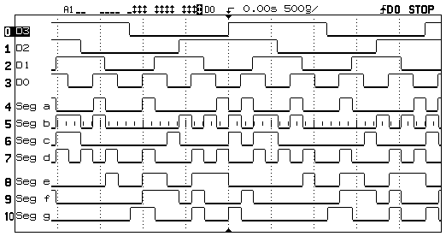
Hardware Verification

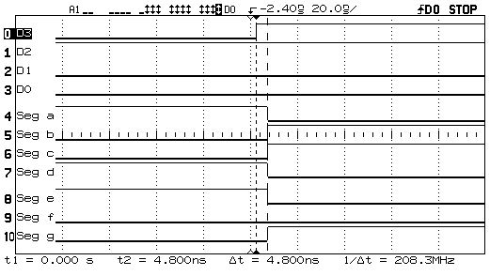
Input D3 Propagation Delay

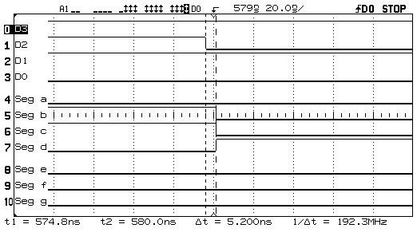
Input D2 Falling Edge Propagation Delay

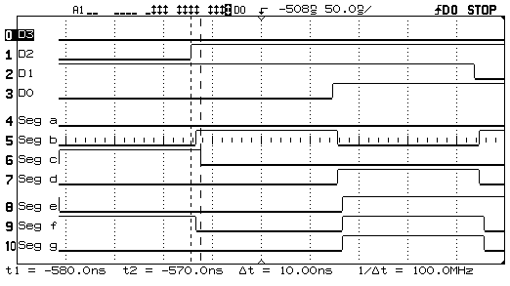
Input D2 Rising Edge Propagation Delay

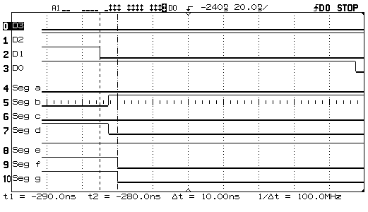
Input D1 Propagation Delay

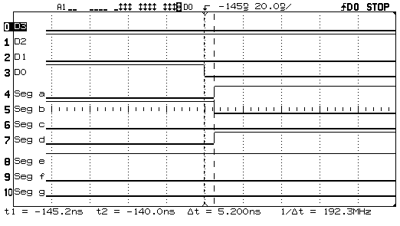
Input D0 Propagation Delay

Appendix M

Propagation Delay Summary

Signal | Propagation | Input Pin |  | Output Pin(s)
Signal | Delay (ns) | Input Pin |  | Output Pin(s)
D3, Rising | 4.800 | 3 |  | 78, 79, 80, 81, 82, 84
D2, Falling | 5.200 | 4 |  | 78, 79, 80
D2, Rising | 10.000 | 4 |  | 80
D1, Falling | 10.000 | 5 |  | 83, 84
D0, Falling | 5.200 | 6 |  | 78, 79, 81

